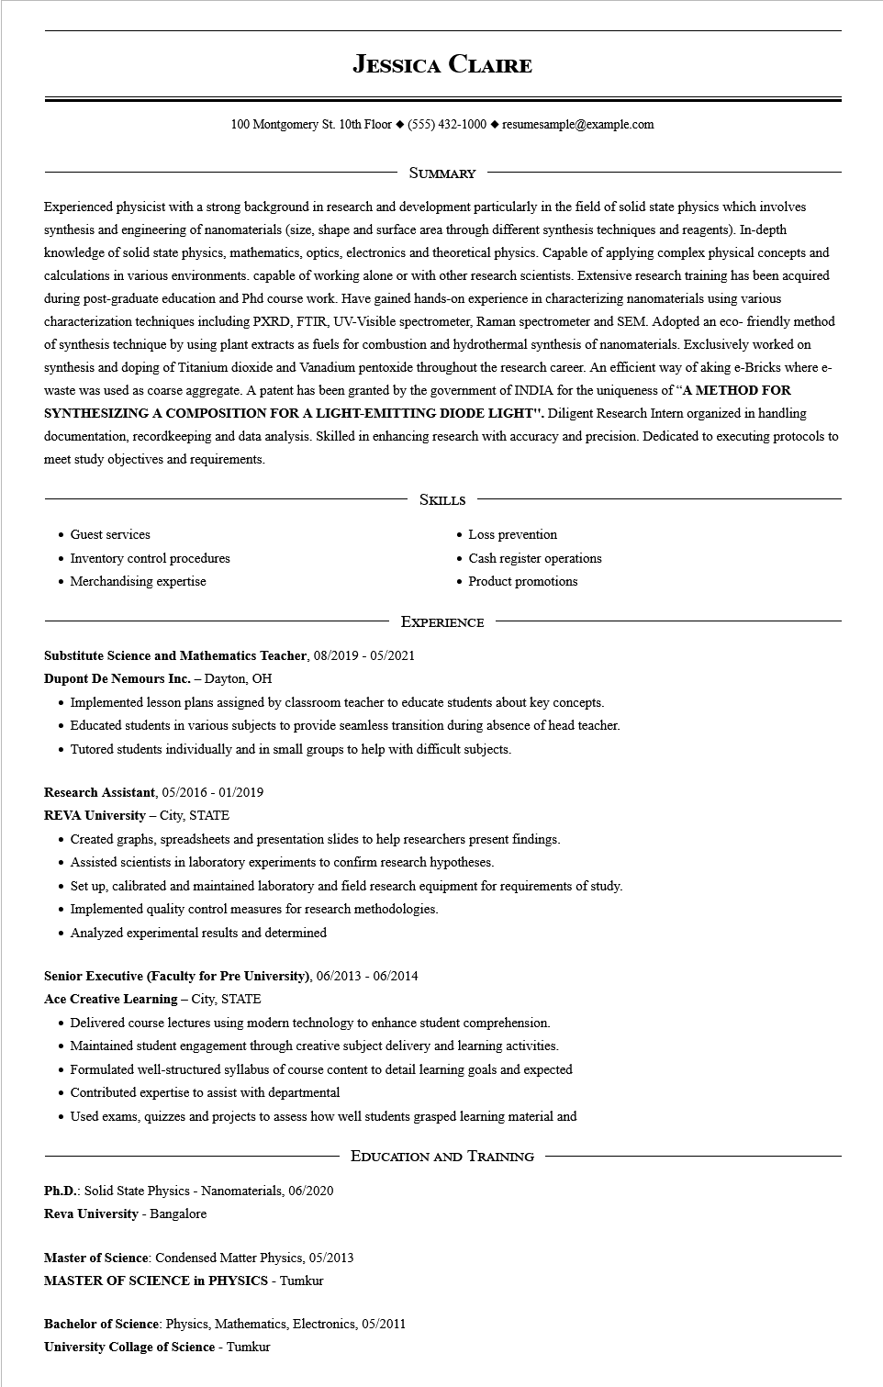
JESSICA CLAIRE
100 Montgomery St. 10th Floor (555) 432-1000◆ resumesample@example.com
SUMMARY
Experienced physicist with a strong background in research and development particularly in the field of solid state physics which involves synthesis and engineering of nanomaterials (size, shape and surface area through different synthesis techniques and reagents). In-depth knowledge of solid state physics, mathematics, optics, electronics and theoretical physics. Capable of applying complex physical concepts and calculations in various environments. capable of working alone or with other research scientists. Extensive research training has been acquired during post-graduate education and Phd course work. Have gained hands-on experience in characterizing nanomaterials using various characterization techniques including PXRD, FTIR, UV-Visible spectrometer, Raman spectrometer and SEM. Adopted an eco-friendly method of synthesis technique by using plant extracts as fuels for combustion and hydrothermal synthesis of nanomaterials. Exclusively worked on synthesis and doping of Titanium dioxide and Vanadium pentoxide throughout the research career. An efficient way of aking e-Bricks where e- waste was used as coarse aggregate. A patent has been granted by the government of INDIA for the uniqueness of "A METHOD FOR SYNTHESIZING A COMPOSITION FOR A LIGHT-EMITTING DIODE LIGHT". Diligent Research Intern organized in handling documentation, recordkeeping and data analysis. Skilled in enhancing research with accuracy and precision. Dedicated to executing protocols to meet study objectives and requirements.
• Guest services
• Inventory control procedures
• Merchandising expertise
SKILLS
• Loss prevention
• Cash register operations
• Product promotions
EXPERIENCE
Substitute Science and Mathematics Teacher, 08/2019 - 05/2021
Dupont De Nemours Inc. - Dayton, OH
• Implemented lesson plans assigned by classroom teacher to educate students about key concepts.
• Educated students in various subjects to provide seamless transition during absence of head teacher.
• Tutored students individually and in small groups to help with difficult subjects.
Research Assistant, 05/2016 - 01/2019
REVA University - City, STATE
• Created graphs, spreadsheets and presentation slides to help researchers present findings.
• Assisted scientists in laboratory experiments to confirm research hypotheses.
• Set up, calibrated and maintained laboratory and field research equipment for requirements of study.
• Implemented quality control measures for research methodologies.
• Analyzed experimental results and determined
Senior Executive (Faculty for Pre University), 06/2013 - 06/2014
Ace Creative Learning - City, STATE
• Delivered course lectures using modern technology to enhance student comprehension.
• Maintained student engagement through creative subject delivery and learning activities.
• Formulated well-structured syllabus of course content to detail learning goals and expected • Contributed expertise to assist with departmental
• Used exams, quizzes and projects to assess how well students grasped learning material and
EDUCATION AND TRAINING
Ph.D.: Solid State Physics - Nanomaterials, 06/2020
Reva University - Bangalore
Master of Science: Condensed Matter Physics, 05/2013
MASTER OF SCIENCE in PHYSICS - Tumkur
Bachelor of Science: Physics, Mathematics, Electronics, 05/2011 University Collage of Science - Tumkur

